Freight services UK to Ivory Coast

Shipping to Côte d'Ivoire has never been easier, we provide competitive rates for door to port and door to door cargo service to Abidjan. If you are international student, relocating to Ivory Coast or do business in Ethiopia we are here to take care of all your export needs from UK to Côte d'Ivoire.

AIRPORT TO AIRPORT
Country | City | Airport Code | +100 kg | +500 kg | +1000 kg | Handling & Documentation
Ivory Coast | Abidjan | ABJ | £3.75/kg | £3.50/kg | £3.25/kg | £50 per shipment
- Up-to Abidjan Airport only
- Minimum weight charged is 100 kg
- Transit time 3-5 days Variable
- Destination charges may apply, such as taxes, airport charges etc...
- This is the quickest and cheapest way to ship to Côte d'Ivoire by air
- We can arrange shipment collections from any UK address, please contact Us

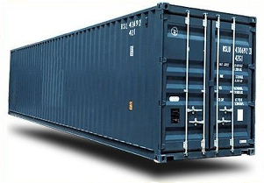 | Full container load to port of Abidjan send us your requirements and we will revert with quote.  WhatsApp: +447375964786  Email: info@directcargoexpress.com

Côte d'Ivoire is a West African country with beach resorts, rainforests and a French-colonial legacy. Abidjan, on the Atlantic coast, is the country’s major urban center. Its modern landmarks include zigguratlike, concrete La Pyramide and St. Paul's Cathedral, a swooping structure tethered to a massive cross. North of the central business district, Banco National Park is a rainforest preserve with hiking trails. The population of Ivory Coast is 27.48 million and it's capital is Yamoussoukro.

